

****Year 10 General Chemistry****

****Atomic structure and the periodic table****

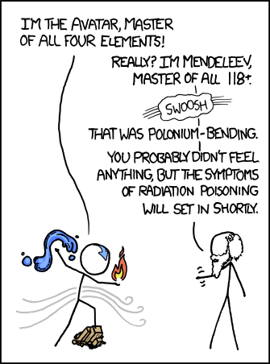

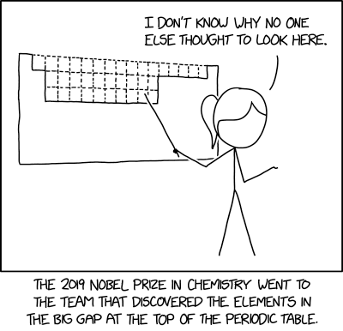

(Munroe, 2011)(Munroe, 2019)

**Name: ______________________**

## **Program**

|  |  |  |  |
| --- | --- | --- | --- |
| **W** | **L** | **Topic** | **Education Perfect Review** |
| 8 | 1 | WA Day |  |
| 2 | Exams |  |
| 3 | Exams |  |
| 4 | Atoms and isotopes | The Structure of an Atom, Atomic Symbols |
| 5 | Electron shells | What are Isotopes? |
| 9 | 1 | Electron dot diagrams |  |
| 2 | Electron configurations | Electron Configuration |
| 3 | Periodic table | The Periodic Table, Groups 1 and 2, Group 17, Group 18 |
| 4 | Ions | What are Ions? |
| 5 | Ionic, covalent or metallic |  |
| 10 | 1 | Writing ionic formulae | Ionic Compounds |
| 2 | Naming ionic substances | Naming Ionic Compounds |
| 3 | Writing covalent formulae |  |
| 4 | Naming covalent substances |  |
| 5 | Balancing equations | Reactants and Products: Reaction in Action, Writing Word Equations |
| 11 | 1 | Balancing equations | Writing Chemical and Molecular Equations, Balancing Equations |
| 2 | Revision | Writing Chemical Equations 1, Writing Chemical Equations 2 |
| 3 | Revision | Balancing Chemical Equations |
| 4 | **Mid-topic Test** |  |
| 5 | PL Day |  |
| 1 | 1 | Labour Day |  |
| 2 | Collision theory | Extension: Collision Theory |
| 3 | Rate of reaction | Rate of Reaction |
| 4 | Test review |  |
| 5 | Carbon dioxide |  |
| 2 | 1 | Acid-carbonate reactions | Acid Reactions |
| 2 | Making carbon dioxide practical |  |
| 3 | Changing reaction rate - CO2 | Agitation, Concentration and Surface Area |
| 4 | Hydrogen |  |
| 5 | Acid-metal reactions | Metal Reactions with Acid |
| 3 | 1 | Making hydrogen practical |  |
| 2 | Changing reaction rate - H2 |  |
| 3 | Oxygen |  |
| 4 | Decomposition reactions | Combination and Decomposition Reactions |
| 5 | Making oxygen practical |  |

|  |  |  |  |
| --- | --- | --- | --- |
| 4 | 1 | Changing reaction rate - O2 | Activation Energy, Temperature and Catalysts |
| 2 | Factors affecting reaction rate | Extension: Factors Affecting Reaction Rates |
| 3 | Revision |  |
| 4 | **Reaction rates - Validation** |  |
| 5 | Revision |  |
| 5 | 1 | Revision |  |
| 2 | Test review |  |
| 3 | Revision |  |
| 4 | **Topic Test** |  |
| 5 |  |  |
| 6 | 1 | PL Day |  |
| 2 | Test review |  |
| 3 | New rotation |  |
| 4 | New rotation |  |
| 5 | New rotation |  |

## **Assessment Outline**

|  |  |
| --- | --- |
| **Task** | **Weighting** |
| Mid-topic Test | 17% |
| Reaction Rates Validation | 18% |
| Topic Test | 25% |
| Exam | 40% |
| **Total** | **100%** |

## **SCSA Curriculum Statements**

**T**he atomic structure and properties of elements are used to organise them in the Periodic Table (ACSSU186)

Different types of chemical reactions are used to produce a range of products and can occur at different rates (ACSSU187)

## **SCSA Judging Standards**

|  |  |
| --- | --- |
| **A** – Excellent Achievement | Uses the position of elements in the periodic table to determine their atomic structure and electron configuration, and makes predictions about bonding types and reactivity of elements.  Creates balanced chemical equations to predict the products of unfamiliar reactions.  Applies the particle model to explain how different factors influence the rate of reactions in terms of bonding. |
| **B** – High Achievement | Uses the position of elements in the periodic table to determine their atomic structure and electron configuration, and makes predictions about chemical properties and reactivity.  Creates balanced chemical equations for characteristic reactions and their products. Applies the particle model to explain how factors influence the rate of reactions in terms of collisions. |
| **C** – Satisfactory Achievement | Uses the position of elements in the periodic table to make some correct predictions about their observable properties.  Explains how chemical reactions produce particular products using word equations, and describes how some factors influence the rate of reactions. |

## Atomic Structure

An atom is the basic building block of all matter. It is made of smaller particles known as protons, neutrons, and electrons.

|  |  |  |  |
| --- | --- | --- | --- |
| **Particle** | **Charge** | **Mass** | **Position** |
| Proton | +1 | 1 | nucleus |
| Neutron | 0 | 1 | nucleus |
| Electron | -1 | 0.0005 | area around nucleus |

Protons and neutrons sit together in the center of the atom, this is known as the nucleus and it contains (almost) all the atom’s mass.

Electrons are outside the nucleus; they can be thought of as orbiting the nucleus. The electrons are arranged in layers known as shells or energy levels, these are responsible for most of an atom’s size.

Electron shell

Electron (e-)

Proton (p+)

Neutron (n)

Nucleus

## Elements

Atoms with different numbers of protons have different chemical properties, these are known as different elements.

For example, any atom with 1 proton is known as the element hydrogen, while any atom with 6 protons is the element carbon.

The number of protons an atom has is known as its atomic number, different elements have different atomic numbers.

Each element is given its own symbol of one to two letters with the first letter capitalized. These symbols typically come from the name of the element but can be confusing if they have come from the old Latin or German name for the element.

For example, hydrogen (1 proton) is H, gold (79 protons) is Au.

## Isotopes

Two atoms with the same number of protons can still have different numbers of neutrons. Since they have the same number of protons, they are the same element, but they will have different physical properties.

Isotopes are versions of an element with the same number of protons but with different numbers of neutrons.

The number of protons and neutrons an atom has is known as its mass number, different isotopes have different mass numbers.

## Referring to specific isotopes

When referring to a specific atom we need to specify how many protons and neutrons it has, this is commonly done in two ways:

In the first format, the larger number is the mass number (number of protons + neutrons). The smaller number is the atomic number (number of protons). The symbol can also be used to find the number of protons by referring to the periodic table.

C-12

In the second format, just the mass number is written after the symbol.

On the periodic table the atomic number for an element is written on top while the average mass number of its isotopes is written underneath.

6

**C**

12.01

|  |  |  |
| --- | --- | --- |
| Natural Isotopes of Carbon | | |
|  |  |  |
| Carbon-12  6 protons, 6 neutrons | Carbon-13  6 protons, 7 neutrons | Carbon-14  6 protons, 8 neutrons |

**Examples**

|  |  |  |  |
| --- | --- | --- | --- |
| Isotope | Number of protons | Number of neutrons | Mass number |
|  |  |  |  |
|  | 6 |  | 13 |
|  | 6 | 8 |  |
|  |  |  |  |
|  |  |  |  |
|  | 1 | 0 |  |
|  | 1 | 1 |  |
|  | 1 | 2 |  |

Draw labelled diagrams of the following atoms. Make sure you label the nucleus, protons, neutrons and electrons.

1. The C-13 isotope.
2. A lithium atom with a mass number of 7.
3. A chlorine atom with 18 neutrons.

## Electron Arrangement

The electrons in an atom are arranged in layers known as electron shells or electron energy levels.

* A neutral atom will have the same total number of electrons as protons.
* Each shell can hold a certain number of electrons.
* The shells fill up in order from the innermost shell outwards.
* No electrons can be added to a shell until the shells below it are full.

For the first 20 elements:

|  |  |
| --- | --- |
| **Electron shell** | **Maximum number of electrons** |
| 1st | 2 |
| 2nd | 8 |
| 3rd | 8 |
| 4th | 2 |

## Electron shell diagrams

The arrangement of electrons in an atom can be shown using an electron shell or electron energy level diagram.

The shells are drawn as concentric circles around the nucleus. Electrons are shown as dots or crosses on the shells.

4th shell takes remaining 2 electrons

3rd shell holds 8 electrons

2nd shell holds 8 electrons

1st shell holds 2 electrons

nucleus

|  |  |
| --- | --- |
| Boron (B ) 5 | Neon (Ne) 10 |
| Beryllium (Be) 4 | Fluorine (F) 9 |
| Lithium (Li) 3 | Oxygen (O) 8 |
| Helium (He) 2 | Nitrogen (N) 7 |
| Hydrogen (H) 1  Draw the electron shell diagrams of the following elements. | Carbon (C) 6 |
| Phosphorous (P) 15 | Calcium (Ca) 20 |
| Silicon (Si) 14 | Potassium (K) 19 |
| Aluminium (Al) 13 | Argon (Ar) 18 |
| Magnesium (Mg) 12 | Chlorine (Cl) 17 |
| Sodium (Na) 11 | Sulfur (S) 16 |

## Electron dot (Lewis) diagrams

In chemistry we are often most interested in the electrons in the outermost shell, these are known as valence electrons and the outermost shell is known as the valence shell.

Electron shell diagrams are space- and time-consuming to draw so the just the valence electrons can be shown using a Lewis dot or electron dot diagram.

The valence electrons are shown as dots or crosses around the symbol of the element. No circles are drawn.

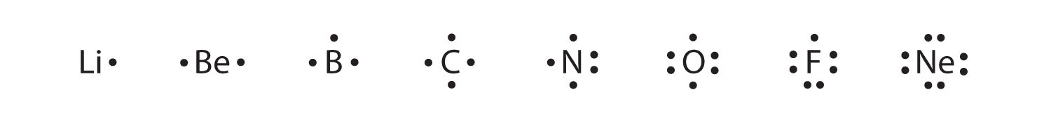

**Electron dot (Lewis) diagrams for ions**

Atoms can gain or lose electrons forming ions. This will give them a charge because they will have different numbers of protons and neutrons.

The ion’s diagram is written in square brackets with the charge shown in superscript after the brackets.

Positive ions – lose all valence electrons, will have no dots.

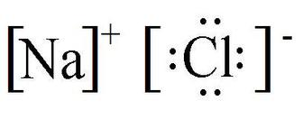

Negative ions – gain enough valence electrons to fill valence shell, will have 8 dots.

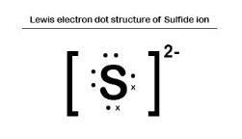

**Electron dot (Lewis) diagrams for ionic compounds**

Dot diagrams for ions written next to each other, positive ion first. Numbers added in front where more than one copy of an ion is needed.

e.g. lithium oxide Li2O aluminium chloride CaCl2

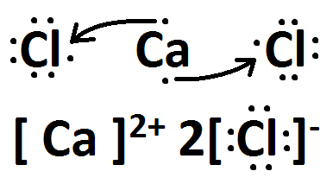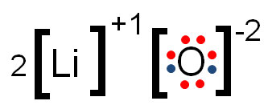

**Electron dot (Lewis) diagrams for molecules**

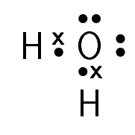**Atoms in molecules share electrons so one electron can count towards a full shell for two different atoms.**

**e.g. water H2O**

Draw electron (Lewis) dot diagrams for the following:

Mg Mg2+

S S2-

Cl2 O2

H2O MgCl2

## Electron configurations

The third alternative for representing the arrangement of electrons in an atom is known as an electron configuration. The number of electrons in each shell are written in order, inside brackets, separated by commas.

e.g. C: (2,4) Ca: (2,8,8,2)

|  |  |  |  |  |
| --- | --- | --- | --- | --- |
| **Lewis Diagram** |  |  |  |  |
| **Number of valence electrons** |  |  |  |  |
| **Electron configuration** |  |  |  |  |
| **Electron shell diagram** |  |  |  |  |
| **Atomic number** |  |  |  |  |
| **Element** | He | N | Na | Ca |

## Periodic Table

The elements can be arranged in order of atomic number, then placed in rows based on the number of electrons shells they have, and columns based on how many valence electrons they have.

This arrangement can be refined by considering the properties of the elements and leads to the periodic table.

The columns are known as groups, the group number of an element is related to its number of valence electrons.

e.g., group 1 elements have 1 valence electron, group 13 elements have 3 valence electrons

The rows are known as periods, the period number of an element determines its number of electron shells.

e.g., period 3 elements have 3 electron shells

**Details**

* Elements in the top right-hand corner are non-metals, the rest are metals
* Group 1 elements are known as alkali metals
* Group 2 elements are known as alkaline earth metals
* Group 17 elements are known as halogens
* 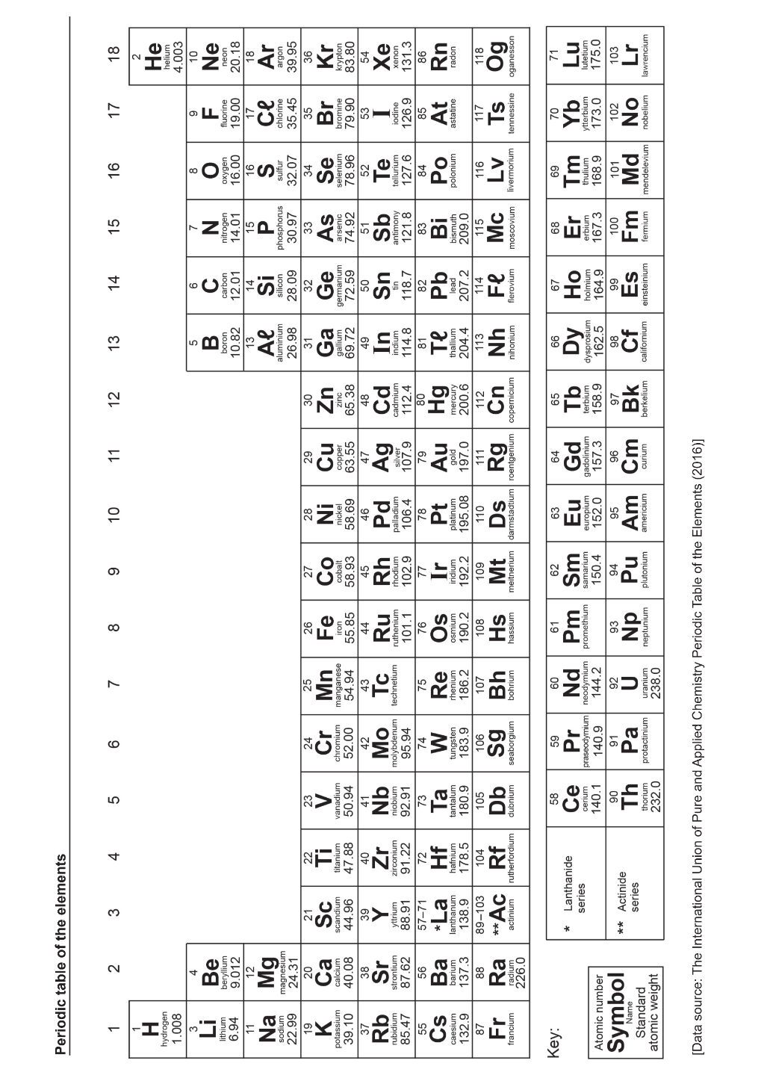Group 18 elements are known as noble gases
* H, N, O, F, Cl, Br and I are diatomic (exist naturally as a molecule of 2 atoms)
* Only Hg and Br are liquids at room temperature
* Elements with no mass number are always radioactive
* Elements 95+ do not occur naturally in the universe

Transition

Metals

## Ions

Most atoms will easily gain or lose electrons to obtain a full outer (valence) shell. This movement of electrons is the basis of most chemical reactions.

* **Anions**: non-metals will typically gain electrons to fill up their outside shell, they will end up with more electrons than protons so they will be negatively charged
* **Cations:** metals will typically lose the electrons in their outside shell, leaving the next shell down full, they will end up with more protons than electrons so they will be positively charged

When an ion is written, its charge is noted in superscript after the symbol.

e.g., calcium ion: Ca2+

|  |  |  |  |  |  |  |
| --- | --- | --- | --- | --- | --- | --- |
|  | Species | Cation or Anion | Atomic number (#p) | Number of electrons | Number of neutrons | Mass number (#p+#n) |
| a |  |  | 13 |  |  |  |
| b |  |  |  | 18 | 16 | 31 |
| c |  |  | 17 | 18 | 18 |  |
| d |  |  | 3 | 2 |  | 7 |
| e |  |  |  |  | 8 |  |
| f |  |  |  |  | 8 |  |
| g |  |  | 18 | 18 | 22 |  |
| h |  |  |  | 10 |  | 24 |

|  |  |  |  |  |  |  |
| --- | --- | --- | --- | --- | --- | --- |
| Electrons |  |  |  |  |  |  |
| Neutrons |  |  | 60 |  |  | 44 |
| Protons |  |  |  |  |  | 35 |
| Mass number |  |  |  |  |  |  |
| Atomic number |  |  | 47 |  |  |  |
| Species |  |  |  |  |  |  |

|  |  |  |  |  |
| --- | --- | --- | --- | --- |
| Electron configuration |  |  |  |  |
| Shell diagram |  |  |  |  |
| Electrons | 11 | 18 | 10 |  |
| Neutrons |  | 20 |  | 18 |
| Protons |  |  |  | 17 |
| Mass number |  | 40 | 16 |  |
| Atomic number | 11 |  | 8 | 17 |
| Species |  |  |  |  |

|  |  |  |  |  |  |  |  |
| --- | --- | --- | --- | --- | --- | --- | --- |
| Lewis diagram |  |  |  |  |  | How to Draw a Lewis Dot Structure: A Complete Guide |  |
| Electron configuration |  |  |  | (2,8,8) |  |  |  |
| Electrons |  | 15 |  |  |  | 5 |  |
| Neutrons |  | 16 |  |  | 4 | 6 |  |
| Mass number | 31 |  |  | 40 |  |  | 32 |
| Atomic number | 15 |  |  |  | 3 | 5 |  |
| Charge | -3 | 0 |  | +1 | +1 |  |  |
| Species |  |  |  |  |  |  |  |

**Ionic Compounds**

Ionic compounds form when a **metal combines with a non-metal** e.g., sodium chloride - NaCl.

The exception is ammonium compounds, which are also ionic   
e.g., ammonium chloride - NH4Cl

The metal will be a cation (positive ion), and the non-metal will be an anion (negative ion)

**Writing formulae for ionic compounds**

1. Identify the cation and write down its symbol and charge.
2. Identify the anion and write down its symbol and charge.

(Some ions are polyatomic e.g. ammonium, NH4+, and nitrate, NO3-. The polyatomic ions are found on the ions table.)

1. Combine the two ions to form an electrically neutral compound.

There are two ways to do this:

Method 1 - Decide how many of each ion is needed for the positive and negative charges to cancel each other out. (Lowest Common Multiple)

OR

Method 2 - Swap and drop (and simplify) the values of the charges.

* Example: Write the formulae for aluminum nitride and lithium oxide.

Method 1 – Lowest Common Multiple

|  |  |  |
| --- | --- | --- |
|  | aluminium nitride | lithium oxide |
| Identify the cation and anion. Write down their symbol and charge. | Al+3 N-3 | Li+ O-2 |
| Use a multiplier for the cation and anion each to make the charges equal. | (+3) x 1 = (-3) x 1 | (+1) x 2 = (-2) x 1 |
| Write each multiplier as a subscript after the symbol. | Al1N1 | Li2O1 |
| Write the final formula. Leave out subscripts that are one. There must be no charges in the final formula. | AlN | Li2O |

Method 2 – Swap and Drop

|  |  |  |
| --- | --- | --- |
|  | aluminium nitride | lithium oxide |
| Identify the cation and anion. Write down their symbol and charge. | Al+3 N-3 | Li+ O-2 |
| Swap only the charge number of the cation to become the subscript of the anion and vice versa. | Al3N3 | Li2O1 |
| Simplify to the lowest ratio. | Al1N1 | Li2O1 |
| Write the final formula. Leave out subscripts that are one. There must be no charges in the final formula. | AlN | Li2O |

**Naming ionic compounds**

1. The cation is named first, then the anion.
2. Names of ions can all be found on the ions table.
3. You do not need to indicate how many ions are present eg Na3N is named sodium nitride, it is **not** named trisodium nitride.

**Ionic compounds - writing formula and naming**

Remember, ionic compounds are formed between a metal (or ammonium) and a non-metal.

|  |  |
| --- | --- |
| **Name** | **Formula** |
| potassium chloride |  |
| magnesium chloride |  |
| aluminium chloride |  |
| sodium nitrate |  |
| sodium carbonate |  |
| sodium phosphate |  |
| calcium nitrate |  |
| calcium nitride |  |
| zinc sulfate |  |
| zinc sulfide |  |
| iron (II) oxide |  |
| iron (III) oxide |  |
| copper (I) hydroxide |  |
| copper (II) hydroxide |  |
| ammonium nitrate |  |
| ammonium iodide |  |
| ammonium sulfate |  |
|  | AgCl |
|  | AgCH3COO |
|  | Ag2O |
|  | MgO |
|  | Mg3(PO4)2 |
|  | FeCO3 |
|  | Fe2(CO3)3 |
|  | NaHCO3 |
|  | Ba(CH3COO)2 |
|  | Cr2S3 |

**Covalent Compounds**

Covalent compounds form when **non-metal elements** combine   
e.g., carbon dioxide - CO2.

**Writing covalent formulae**

1. Write down the symbol of the first element named followed by the symbol of the second element named.
2. Use numerical prefixes to identify the number of atoms of each element in the molecule of the compound.

|  |  |
| --- | --- |
| Prefix on the name of the element | Number of atoms in compound |
| mono | 1 |
| di | 2 |
| tri | 3 |
| tetra | 4 |
| penta | 5 |
| hexa | 6 |
| hepta | 7 |
| octa | 8 |
| nona | 9 |
| deca | 10 |

* Example: Write the formula of sulfur trioxide and dinitrogen pentoxide

|  |  |  |
| --- | --- | --- |
|  | sulfur trioxide | dinitrogen pentoxide |
| Write down the symbol of the first element named followed by the symbol of the second element named. | S O | N O |
| Use numerical subscripts to identify the number of atoms of each element. | SO3 | N2O5 |

**Naming covalent compounds**

1. Name the first element listed in the compound.
2. Name the second element listed and give it the suffix ‘*ide’*.
3. Use numerical prefixes to specify the number of atoms in the molecule of the compound. No prefix is given to the first element’s name if there is only one atom e.g., CO2 is named carbon dioxide, not monocarbon dioxide.

**Covalent compounds -** **writing formulae and naming**

Remember covalent compounds are formed when non-metals combine.

|  |  |
| --- | --- |
| **Name** | **Formula** |
|  | SO2 |
|  | SO3 |
| carbon monoxide |  |
| carbon dioxide |  |
| trisulfur octaoxide |  |
|  | P2F6 |
|  | N2O5 |
|  | N2O3 |

**Covalent compounds known by their common name are:**

**Water - H2O**

**Ammonia - NH3**

**Organic compounds like methane CH4 are named by a system you will learn in ATAR Chemistry.**

**Acidshave their own names, which can be found on the ions table:**

**Hydrochloric acid HCl**

**Ethanoic (acetic) acid CH3COOH**

**Nitric acid HNO3**

**Sulfuric acid H2SO4**

**Carbonic acid H2CO3**

**Diatomic elements**

Some elements exist as molecules of two atoms and are called diatomic elements. They are hydrogen, nitrogen, oxygen, fluorine, chlorine, bromine and iodine and in chemical equations are written as: H2, N2, O2,F2, Cl2, Br2 & I2

**Naming summary**

**Element**

**Step 2:** look up name of element on periodic table

**Ionic**

**Step 2:** look up first symbol on ions table, write name

**Step 3:** look up the rest of the formula on ions table, write name

First symbol is a metal (or starts with NH4)

Only one symbol

Only contains non-metals

**Covalent**

**Step 2:** look up names of elements on periodic table, write in order

**Step 3:** change ending of last element to ‘ide’

**Step 4:** add prefixes to show how many of each element there are

1 – mono 6 - hexa

2 – di 7 - hepta

3 – tri 8 - octa

4 – tetra 9 - nona

5 – penta 10 - deca

**Step 1:** Element, Ionic or Covalent?

**Chemical Equations**

In a chemical reaction, atoms are rearranged to change one or more substances into one or more new substances. This can be shown using a chemical equation.

The starting substances are known as reactants and are shown before the arrow. The final products are shown after the arrow.

Substances are shown as formulae, with coefficients in front to show how many of that substance is involved. If no coefficient is written, there is only one of that substance.

For example, the fuel propane can be burnt with oxygen to create water and carbon dioxide:

C3H8 + 5O2 → 3CO2 + 4H2O

The subscript numbers are part of the formulae, e.g., water is H2O, it is made of two hydrogens with one oxygen.

The full-size numbers in front are the coefficients, they indicate how many of that substance is present, this equation says that one propane can be burnt with five oxygen to produce three carbon dioxide and four water.

**The Law of Conservation of Mass**

In a chemical reaction, atoms are not created or destroyed, they are only rearranged to produce new products. Therefore, there must be the same number of atoms in the reactants as in the products. This is shown by a balanced chemical equation and is known as the law of conservation of mass which states that “the mass of the reactants in a chemical reaction is equal to the mass of the products”.

Determine the number of each of the different types of atoms in the reactants and the products and then decide if the equation is balanced or unbalanced.

1. C3H8 + 5O2 → 3CO2 + 4H2O  
    propane oxygen carbon dioxide water  
     
   **Reactants: Products:**  
   Carbon (C) = ___ Carbon (C) = ___  
   Hydrogen (H) = ___ Hydrogen (H) = ___

Oxygen (O) = ___ Oxygen (O) = ___

Balanced or unbalanced: _____________

1. H2SO4 + 2NaOH → Na2SO4 + H2O  
    sulfuric acid sodium hydroxide sodium sulfate water  
     
   **Reactants: Products:**  
   Sodium (Na) = ___ Sodium (Na) = ___  
   Sulfur (S) = ___ Sulfur (S) = ___  
   Hydrogen (H) = ___ Hydrogen (H) = ___

Oxygen (O) = ___ Oxygen (O) = ___

Balanced or unbalanced: _____________

1. SO3 + H2O → H2SO4 sulfur trioxide water sulfuric acid  
     
   **Reactants: Products:**  
   Sulfur (S) = ___ Sulfur (S) = ___  
   Hydrogen (H) = ___ Hydrogen (H) = ___

Oxygen (O) = ___ Oxygen (O) = ___

Balanced or unbalanced: _____________

1. C4H10 + 6O2 → 4CO2 + 5H2O  
    butane oxygen carbon dioxide water  
     
   **Reactants: Products:**  
   Carbon (C) = ___ Carbon (C) = ___  
   Hydrogen (H) = ___ Hydrogen (H) = ___

Oxygen (O) = ___ Oxygen (O) = ___

Balanced or unbalanced: _____________

**Balancing chemical equations**

An unbalanced equation can be balanced by adding or changing coefficients in front of the formulae:

H2 + N2 → NH3 is unbalanced

3H2 + N2 → 2NH3 is balanced

It is important that you only change the coefficients, you cannot change the formulae at this stage, do not change or add subscript numbers.

General method:

1. Pick an element (leave oxygen until last and hydrogen until second last).
2. Determine how many of that element there are in the reactants, and how many there are in the products.
3. Add or change coefficients so that the numbers of the element on either side of the arrow becomes equal.
4. Repeat the process for each element in the reaction until all are equal.

Balance the chemical equations below by filling in the blanks.

1. 3H2 + N2­ → ___NH3 hydrogen nitrogen ammonia
2. ­­­ ___Mg + P4 → 2Mg3P2 magnesium phosphorous magnesium phosphide
3. ___HCl + CuSO4­ → H2SO4 + CuCl2 hydrochloric acid copper (II) sulfate sulfuric acid copper (II) chloride
4. 2Al + ___CuO → Al2O3 + ___Cu  
    aluminium copper (II) oxide aluminium oxide copper
5. 3C + ___HNO3 → ___CO2 + 2H2O + ___NO  
    carbon nitric acid carbon dioxide water nitric oxide

Year 10 General Chemistry Quiz

Total: /20

1. Name the following substances. (6 marks)
2. MgO __________________________________________
3. SrSO4 __________________________________________
4. N2 __________________________________________
5. CO __________________________________________
6. FeN __________________________________________
7. AgHSO4 __________________________________________
8. Write the formula for the following substances. (10 marks)
9. calcium sulfide ________________________
10. chromium (III) hydroxide ________________________
11. lithium hydrogencarbonate ________________________
12. tetrasulfur hexafluoride ________________________
13. barium nitrate ________________________
14. sulfuric acid ________________________
15. zinc phosphate ________________________
16. nickel (II) chloride ________________________
17. aluminium carbonate ________________________
18. potassium sulfate ________________________
19. Balance the following equations. (4 marks)
20. C(s) + O2(g) → CO(g)
21. Fe(s) + I2(g) → FeI3(s)
22. C6H14(g) + O2(g) → CO2(g) + H2O(*l*)
23. B2Br6(s)+ HNO3(*aq*) → B(NO3)3(s) + HBr(aq)

Year 10 General Chemistry Quiz

Total: /24

1. Name the following substances. (6 marks)
2. Ag2O __________________________________________
3. CaCO3 __________________________________________
4. NH3 __________________________________________
5. N2O4 __________________________________________
6. Cr2S3 __________________________________________
7. H2CO3 __________________________________________
8. Write the formula for the following substances. (10 marks)
9. potassium nitrate ________________________
10. strontium phosphate ________________________
11. copper (I) nitrate ________________________
12. triphosporus pentoxide ________________________
13. manganese (II) ethanoate ________________________
14. phosphoric acid ________________________
15. gold (I) sulfite ________________________
16. nickel (II) nitride ________________________
17. calcium hydrogensulfate ________________________
18. ammonium iodide ________________________
19. Balance the following equations. (4 marks)
20. H2(g) + O2(g) → H2O(g)
21. N2(g) + H2(g) → NH3(g)
22. C4H10(g) + O2(g) → CO2(g) + H2O(*l*)
23. NaMnO4(aq)+ H2O2(*l*) + H2SO4(aq) → MnSO4(aq) + Na2SO4(aq) + O2(g) + H2O(*l*)
24. Write fully balanced chemical equations for the following reactions. (4 marks)
25. Lithium oxide reacts with water to produce lithium hydroxide
26. Strontium bromide reacts with ammonium carbonate to produce strontium carbonate and ammonium bromide

Year 10 Practice Chemistry Quiz

Total: /21

1. Name the following substances. (6 marks)
2. MnCO3 __________________________________________
3. CuNO3 __________________________________________
4. N2O4 __________________________________________
5. Sr(HSO4)2 __________________________________________
6. NH4F ___________________________________________
7. Ni(CH3COO)2 __________________________________________
8. Write the formula for each of the following substances. (8 marks)
9. sodium nitrate ________________________
10. iron (III) phosphate ________________________
11. calcium nitride ________________________
12. iron (III) sulfide ________________________
13. aluminium iodide ________________________
14. disulfur pentafluoride ________________________
15. copper (II) chloride ________________________
16. zinc hydrogensulfate ________________________
17. Balance the following equations. (3 marks)
18. HgO(s) → Hg(s) + O2(g)
19. C3H6(g) + O2(g) → CO2(g) + H2O(*l*)
20. FeS(s)+ O2(g) → Fe2O3(s) + SO2(g)
21. Write fully balanced chemical equations for the following reactions (you do not have to include states). (4 marks)
22. Calcium metal reacts with water to produce calcium hydroxide and hydrogen gas
23. Chromium (III) hydrogencarbonate decomposes to produce chromium (III) oxide, carbon dioxide and water.

**Rates of Chemical Reactions**

Reaction rate in chemistry is the **speed** at which a chemical reaction occurs. Some reactions occur so quickly that they are explosive e.g., a bomb, and some occur very slowly e.g., the rusting of steel.

The rate at which a reaction occurs depends upon the type of reactants and the conditions under which the reaction takes place. Changing the conditions can change the rate of the reaction. We will study five factors that can change the rate of a chemical reaction. In order to understand how these factors change the rate of a reaction we need to understand what occurs during a chemical reaction. The collision theory enables us to understand and explain changing reaction rates.

**Collision Theory**

For a chemical reaction to occur, the reactant particles must:

* collide with each other.
* collide with each other with a minimum amount of energy, called activation energy.
* collide with each other with the correct orientation.

If we can change the conditions to affect any one of the above, then we can change the rate of the reaction.

**Factors that affect the rate of a reaction**

There are five general factors that can affect the rate of a reaction:

1. Temperature
2. Concentration
3. Agitation
4. Surface area
5. Catalysts (or inhibitors). A catalyst speeds up a reaction, an inhibitor slows it down.

(Light of a particular wavelength may also speed up a reaction)

* 1. **Temperature** – changing the temperature changes the kinetic energy of the particles.

Increasing temperature increases the kinetic energy of the particles and decreasing temperature decreases the kinetic energy of the particles in the reaction.

Increasing temperature will increase **the proportion of collisions that have sufficient kinetic energy to meet the activation energy** which increases the rate of successful collisions and so increases the reaction rate.

Also, by increasing the kinetic energy of the particles, the particles move faster and so the rate of collisions increases which also increases the reaction rate.

The opposite occurs if you decrease the temperature of a reaction.

Decreasing temperature will ______________________________________________________

______________________________________________________________________________

______________________________________________________________________________

______________________________________________________________________________

______________________________________________________________________________

______________________________________________________________________________

______________________________________________________________________________

* 1. **Concentration**

Increasing the concentration of one or more of the reactants decreases the distance between the particles which increases the rate of collisions which increases the reaction rate.

* 1. **Agitation (stirring)**

Agitation increases the number of reactant particles exposed to each other at the same time which increases the rate of collisions which increases the reaction rate.

* 1. **Surface area**

Increasing the surface area of one or more of the reactants exposes more reactant particles to each other at the same time which increases the rate of collisions which increases the reaction rate.

The surface area can be increased by grinding/ breaking up solid reactants into smaller pieces e.g., capsules contain powdered medicine.

* 1. **Catalysts**

These are substances which increase the rate of chemical reactions but are not consumed or chemically changed during the reaction.

Catalysts provide an alternate reaction pathway with a lower activation energy. This means a greater proportion of reactant particles will have sufficient kinetic energy to meet the activation energy which increases the rate of successful collisions which increases the reaction rate.

**Rates of reactions**

* 1. What are the three requirements that have to be met by the reactant particles in order for a chemical reaction to take place?
  2. The rate of a reaction can be increased by five factors ***(list them below)***:

* 1. For each scenario below, state the factor that is being changed to alter the reaction rate.

1. Firewood is chopped into small pieces to make lighting a fire easier.

1. A black powder called manganese dioxide causes hydrogen peroxide to decompose faster than normal. The powder is not used up during the reaction.

1. Food left in the fridge lasts longer than food left out.

1. Coal dust can cause explosions.
   1. Use the collision theory to explain the following observations:

(a) A piece of magnesium metal burns faster in a jar of pure oxygen than in air.

(b) In 2 mol L-1 HCl, iron wool produces hydrogen gas faster than an iron

nail of the same mass.

(c) Hydrogen peroxide takes longer to decompose when it is left in the fridge.

(d) A mixture of petrol and oxygen does not combust until a spark is added.

(e) Marble chips (calcium carbonate) react slowly with ethanoic acid, whereas

powdered calcium carbonate reacts vigorously with the same acid.

****On the one page you will be required to research and fill in the following about the relevant gas:****

1. **The percentage of the gas in the atmosphere**
2. **Two properties of the gas**
3. **Two uses of the gas**
4. **The molar mass**
5. **An interesting fact**
6. **A diagrammatic representation of the gas**

****Carbon dioxide****

|  |  |  |  |
| --- | --- | --- | --- |
|  |  | |  |
|  |  |
|  |  |
|  |  |
|  | |

****Producing carbon dioxide in the laboratory****

**Carbon dioxide can be produced by reacting marble chips with hydrochloric acid. Marble chips contain a high percentage of calcium carbonate.**

****Type of reaction****

**This reaction is known as an **acid-carbonate reaction**.**

****Word equation:****

**hydrochloric acid + calcium carbonate → calcium chloride + water + carbon dioxide**

****Balanced chemical equation:****

****Test for carbon dioxide- limewater test****

**The limewater test is used to test if a gas is carbon dioxide. Lime water is calcium hydroxide dissolved in water.**

1. **Bubble the unknown gas into limewater.**
2. **If the limewater turns milky (white) then the gas is carbon dioxide.**

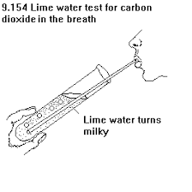****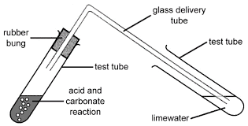****

****Reaction Rate Investigation - Concentration****

****Aim:** To investigate how the concentration of hydrochloric acid affects the rate at which it reacts with marble chips (calcium carbonate)**

****Hypothesis:****

****Variables:****

**Independent:**

**Dependent:**

**Controlled:**

****Method:****

1. **Place one spatula of marble chips into a test tube.**
2. **Set up the equipment as shown below:**

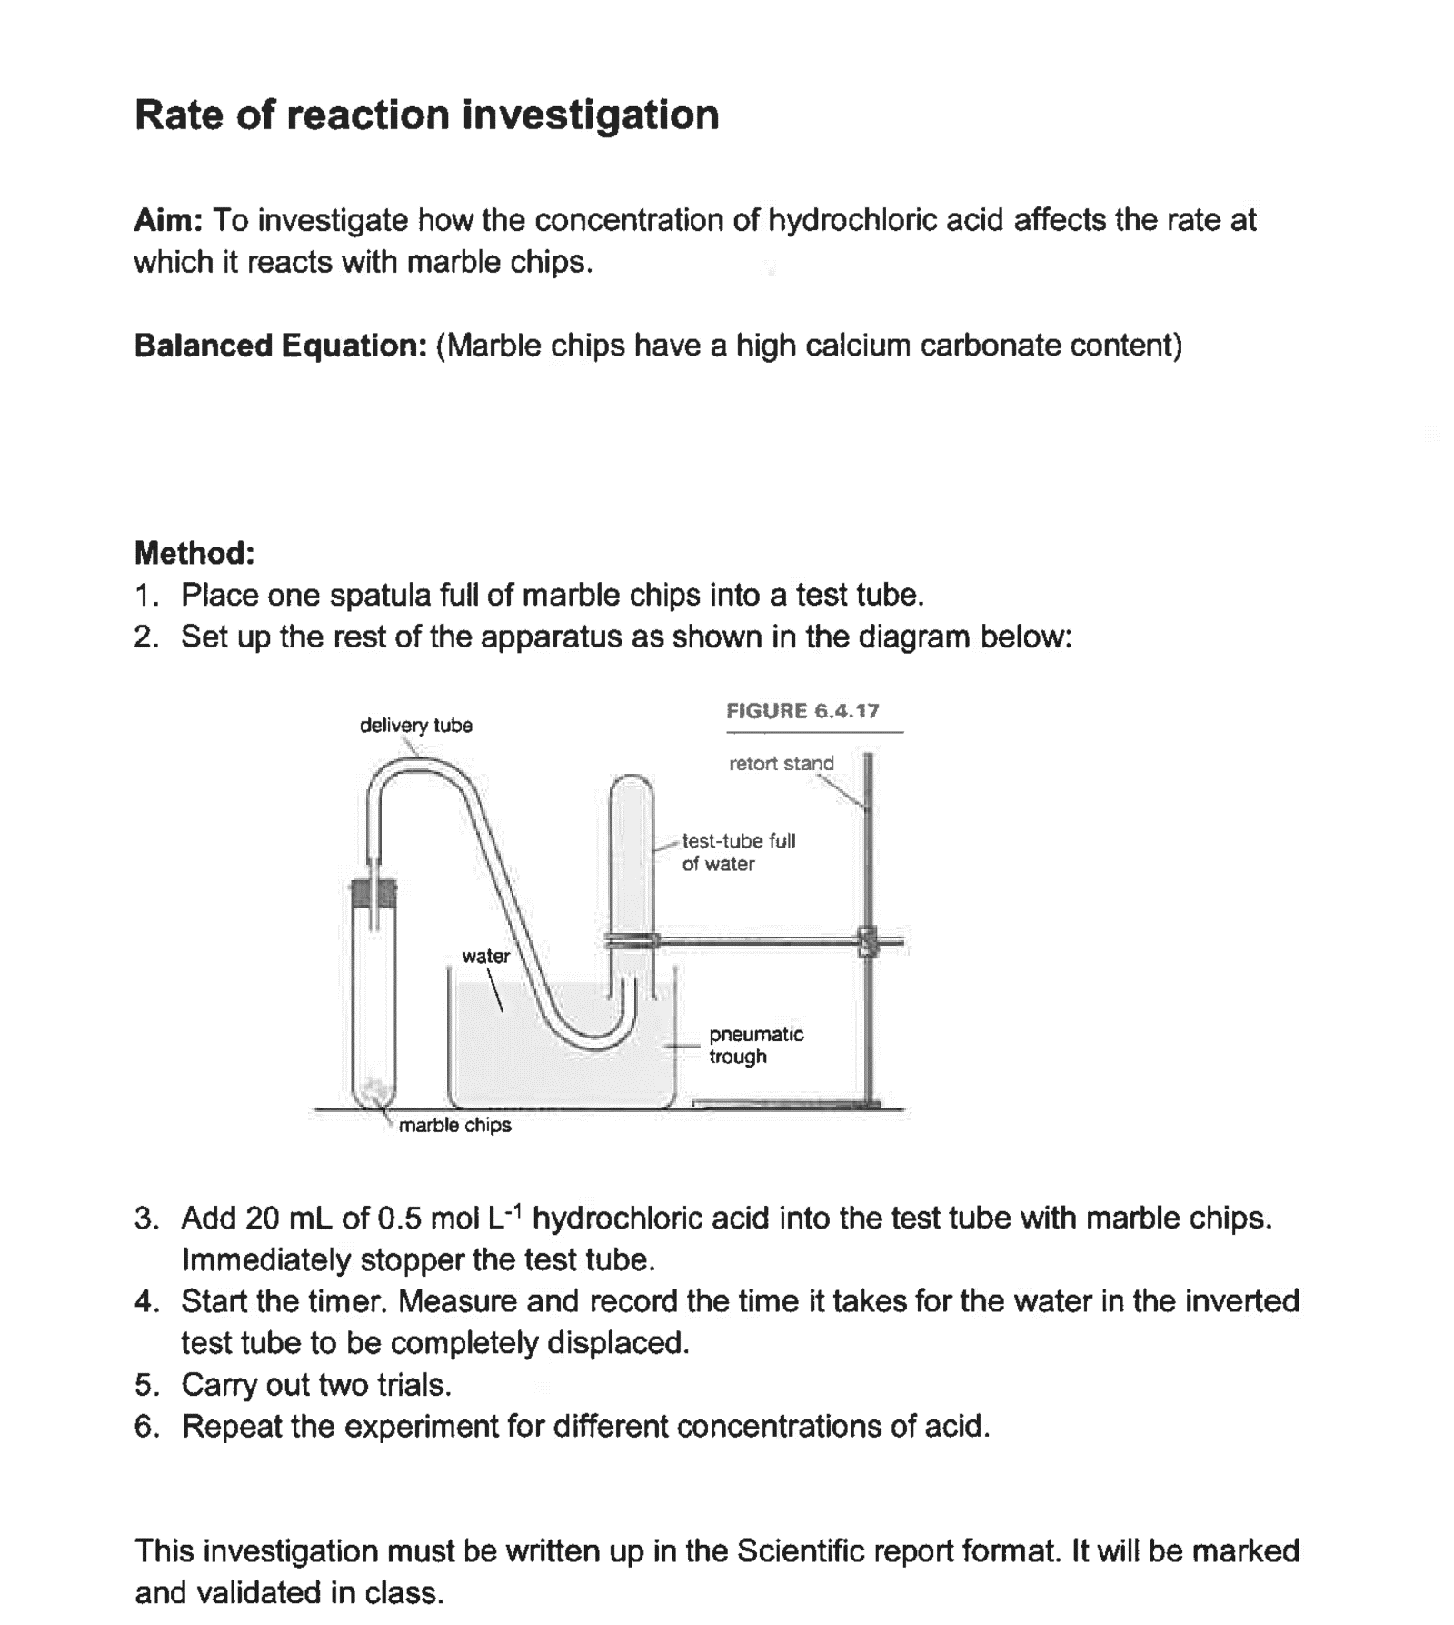

1. **Add 20 mL of 0.5 mol L-1 hydrochloric acid to the test tube with marble chips and immediately stopper the test tube.**
2. **Start the timer. Measure and record the time it takes for the water in the inverted test tube to be completely displaced.**
3. **Carry out two trials.**
4. **Repeat the experiment for different concentrations of acid.**

****Results table:****

|  |  |  |  |
| --- | --- | --- | --- |
| **Concentration**  **(mol L-1)** | **Time (s)** | | |
| **Trial 1** | **Trial 2** | **Average** |
| **0.5** |  |  |  |
| **1.0** |  |  |  |
| **2.0** |  |  |  |

****Graph:****

Graph Title: ……………………………………………………………………………...



****Discussion:****

****What happened?****

****Explain why it happened?****

****Evaluation:****

****Reliability:****

****Accuracy:****

****Validity:****

****Conclusion:****

****Reaction Rate Investigation - Temperature****

****Aim:** To investigate how the temperature of hydrochloric acid affects the rate at which it reacts with marble chips (calcium carbonate)**

****Hypothesis:****

****Variables:****

**Independent:**

**Dependent:**

**Controlled:**

****Method:****

1. **Place one spatula of marble chips into a test tube.**
2. **Set up the equipment as shown below:**



1. **Pour 20 mL of hydrochloric acid into a test tube and place in a water bath to change its temperature. Measure and record the temperature.**
2. **Add the acid the test tube with marble chips and immediately stopper the test tube.**
3. **Start the timer. Measure and record the time it takes for the water in the inverted test tube to be completely displaced.**
4. **Carry out two trials.**
5. **Repeat the experiment for the acid at different temperatures.**

****Results table:****

|  |  |  |  |
| --- | --- | --- | --- |
| **Temperature (°C)** | **Time (s)** | | |
| **Trial 1** | **Trial 2** | **Average** |
|  |  |  |  |
|  |  |  |  |
|  |  |  |  |

****Graph:****

Graph Title: ……………………………………………………………………………...



****Discussion:****

****What happened?****

****Explain why it happened?****

****Evaluation:****

****Reliability:****

****Accuracy:****

****Validity:****

****Conclusion:****

****Reaction Rate Investigation – Surface Area****

****Aim:** To investigate how the surface area of the marble chips affects the rate at which it reacts with hydrochloric acid.**

****Hypothesis:****

****Variables:****

**Independent:**

**Dependent:**

**Controlled:**

****Method:****

1. **Place one spatula of marble chips into a test tube.**
2. **Set up the equipment as shown below:**



1. **Add 20 mL of 1.0 mol L-1 hydrochloric acid to the test tube with marble chips and immediately stopper the test tube.**
2. **Start the timer. Measure and record the time it takes for the water in the inverted test tube to be completely displaced.**
3. **Carry out two trials.**
4. **Use a mortar and pestle to grind one spatula of marble chips into smaller pieces (this increases the surface area). Repeat the experiment using marble chips of different size pieces.**

****Results table:****

|  |  |  |  |
| --- | --- | --- | --- |
| **Surface area** | **Time (s)** | | |
| **Trial 1** | **Trial 2** | **Average** |
| **small (large pieces)** |  |  |  |
| **medium** |  |  |  |
| **Large (small pieces)** |  |  |  |

****Graph:****

Graph Title: ……………………………………………………………………………...



****Discussion:****

****What happened?****

****Explain why it happened?****

****Evaluation:****

****Reliability:****

****Accuracy:****

****Validity:****

****Conclusion:****

|  |  |  |  |
| --- | --- | --- | --- |
|  |  | |  |
|  |  |
|  |  |
|  |  |
|  | |

****Hydrogen****

****Making hydrogen in the laboratory****

**Hydrogen can be made by reacting hydrochloric acid with magnesium.**

****Type of reaction****

**This reaction is known as an **acid-metal reaction**.**

****Word equation:****

**hydrochloric acid + magnesium → magnesium chloride + hydrogen**

****Balanced equation:****

****Outline three ways that the rate of producing hydrogen in the laboratory could be increased.****



****Test for hydrogen- pop test****

1. **Light a match.**
2. **Remove the gas jar lid and place the lit match in the mouth of the gas jar.**
3. **If it makes a “pop” then the gas in the jar is hydrogen.**

****Oxygen****

|  |  |  |  |
| --- | --- | --- | --- |
|  |  | |  |
|  |  |
|  |  |
|  |  |
|  | |

****Making oxygen in the laboratory****

**Oxygen can be made through the decomposition of hydrogen peroxide. Hydrogen peroxide decomposes very slowly to produce water and oxygen gas. By adding a **catalyst**, manganese IV oxide (MnO2), it will decompose rapidly.**

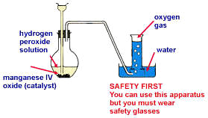

****Type of reaction****

**This reaction is known as a **decomposition reaction**.**

****Word equation:****

**hydrogen peroxide → oxygen + water**

****Balanced equation:****

****Test for oxygen- glowing splint test****

1. **Light a wooden splint and gently blow it out so that it still glows.**
2. **Remove the gas jar lid and place the splint in the mouth of the jar.**
3. **If the glowing splint reignites then the gas in the jar is oxygen**

****Introduction to chemistry calculations – Extension****

****n – mole (mol)****

* In real chemical reactions there are millions of billions of billions of atoms involved – not practical to talk about the actual number of atoms
* Chemists use the word ‘mole’ to refer to a certain number of particles, similar to the word ‘dozen’
* Dozen = 12
* Mole = 6.022 x 1023 = 602 200 000 000 000 000 000 000
* This number is chosen so that the 1 mole of hydrogen atoms weighs 1 g
* Mole is commonly abbreviated to mol

****M – molar mass (g mol-1)****

* The mass numbers on the periodic table are also the molar mass of those elements in   
  g mol-1 – the mass of 1 mole of that element
* These numbers are rarely whole numbers because they are the averages of the natural isotopes for those elements (and another reason that is discussed in ATAR Physics)
* The molar masses on the periodic table apply to the individual elements, but can also be used to find the molar mass of compounds and elemental molecules

****Molar mass of compounds****

* The molar mass of a compound is the sum of the molar masses of each atom in the formula (values on periodic table)
* E.g., M(CO2)=M(C)+M(O)+M(O)=12.01+16.00+16.00= 44.01 g mol-1
* M(Ca3(PO4)2)=3xM(Ca)+2xM(P)+8xM(O)=3x40.08+2x30.97+8x16= 310.18 g mol-1

****Examples****

1. Determine the molar mass of NaCl
2. Determine the molar mass of Al2S3
3. Determine the molar mass of (NH4)2CO3

****Moles equation****

* Main equation used for basic chemistry calculations:

****Examples****

1. Determine the number of moles of CuSO4 in 120 g
2. How many moles is 1.54 kg of Fe2(CO3)3?
3. Calculate the number of moles of ammonium phosphate in 1249 g

****Rearranged equation****

* Can be rearranged to solve for mass – not given to you in assessments

****Examples****

1. Find the mass of 3.47 moles of LiOH
2. Determine the mass of 1.24x103 moles of CaSO4
3. Calculate the mass of 0.495 moles of aluminium carbonate

**Precipitation reactions**

Ionic substances that dissolve in water are referred to as soluble. In water the ions separate and are no longer chemically bound together, this is referred to as a solution.

Ionic substances that do not dissolve are referred to as insoluble. Even in water the ions remain bound together as a compound.

If two solutions are mixed sometimes an insoluble compound can form from the positive ions from one substance with the negative ions from the other. In this case, a solid forms out of the solution. The solid forms as tiny crystals dispersed in the water, this happens instantly and turns the mixture opaque. This is known as a precipitation reaction. Some ions remain dissolved in the water as a solution.

**Subscripts in equations**

In the equations above we have included subscripts in brackets after each species. These show its state; solid, liquid, gas or aqueous (dissolved in water).

|  |  |
| --- | --- |
| (s) | solid |
| (l) | liquid |
| (g) | gas |
| (aq) | aqueous (dissolved in water) |

**Solubility table**

In order to predict the result of these reactions we must understand which ionic substance are soluble and which are insoluble. This can be determined by referring to the solubility tables below, which will be given to you in assessments.

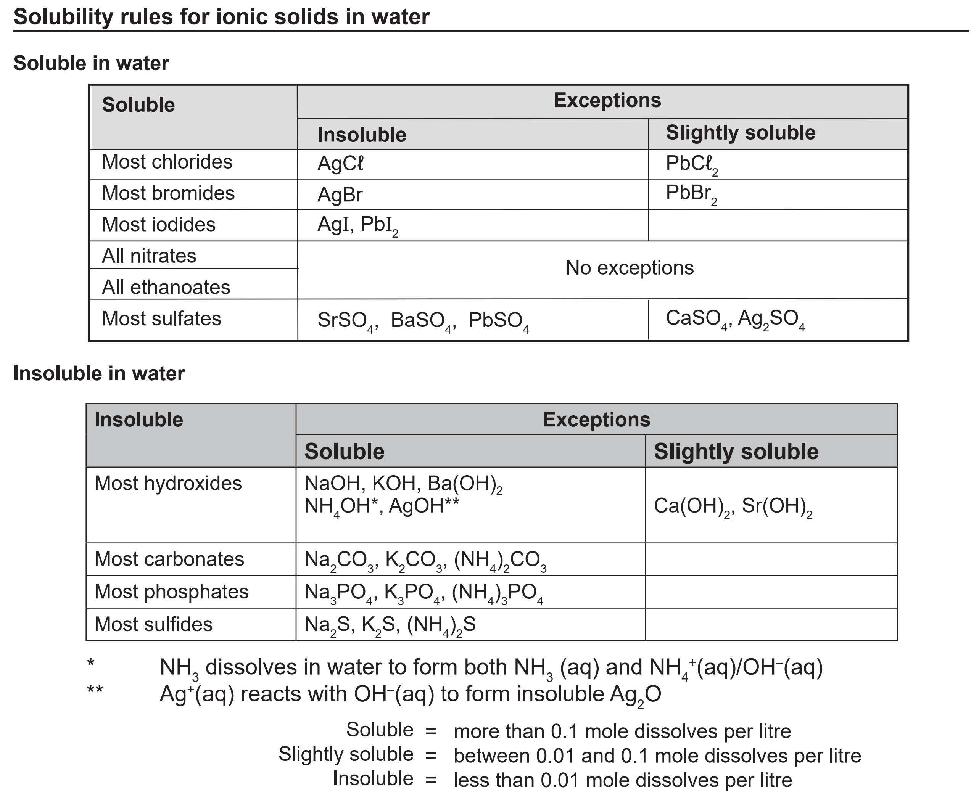

The tables are organized by negative ion, with exceptions listed to the right. Treat anything referred to as slightly soluble as being insoluble.

**Examples**

1. For each of the following substances, determine whether they are soluble or insoluble:
   1. sodium nitrate
   2. potassium carbonate
   3. barium sulfate
   4. calcium hydroxide
   5. lithium chloride
   6. copper (II) sulfide
   7. copper (II) sulfate
   8. ammonium phosphate
   9. lead (II) bromide

**Predicting the products of a possible precipitation reaction**

When two ionic solutions are mixed, we must check if anything insoluble can form from the ions. The simplest way of doing this is a partner swap.

1. Exchange the negative ions of the two ionic compounds e.g.:

Sodium chloride solution is combined with silver nitrate solution.

sodium chloride + silver nitrate → sodium nitrate + silver chloride

NaCl + AgNO3 → NaNO3 + AgCl

1. Then check the solubility of each product (the reactants will always be soluble)

NaCl + AgNO3 → NaNO3 + AgCl

soluble soluble soluble insoluble

1. Add subscripts to show the solubility

NaCl(aq) + AgNO3(aq) → NaNO3(aq) + AgCl(s)

The equation now shows that when solutions of sodium chloride and silver nitrate are mixed, a solid precipitate of silver chloride will form leaving sodium nitrate in solution.

**Both soluble**

If both products are soluble there is no reaction e.g.:

NaCl(aq) + KNO3(aq) → NaNO3(aq) + KCl(aq)

Everything is still dissolved in the water, so instead we write:

NaCl(aq) + KNO3(aq) → no reaction

**Both insoluble**

In certain pairings it is possible for there to be two precipitates e.g.:

Ba(OH)2(aq) + MgSO4(aq) → BaSO4(s) + Mg(OH)2(s)

Make sure you check both.

**Examples**

Write a balanced chemical equation for the following reactions:

1. Solutions of potassium iodide and silver nitrate are mixed
2. solutions of ammonium phosphate and sodium sulfate are mixed
3. solutions of aluminium chloride and sodium hydroxide are mixed
4. solutions of lithium sulfate and calcium nitrate are mixed
5. solutions of iron (III) sulfate and barium hydroxide are mixed
6. solution of ammonium sulfate and barium chloride are mixed
7. solutions of ammonium carbonate and magnesium sulfate are mixed
8. solutions of barium nitrate and copper (II) sulfate are mixed
9. solutions of sodium iodide and lead (II) acetate are mixed
10. solutions of barium nitrate and potassium sulfide are mixed

**Ionic Equations**

Soluble ionic substances in solution do not exist as ionic compounds, the ions separate and move independently. This can be better shown in equations by separating the ions.

E.g.:

NaCl(aq) + AgNO3(aq) → NaNO3(aq) + AgCl(s)

Na+(aq) + Cl-(aq) + Ag+(aq) + NO3-(aq) → Na+(aq) + NO3-(aq) + AgCl(s)

Once this is done, it can be seen that some ions did not change in the reaction, they were present at the start of the reaction, and are present at the end. These are known as spectator ions and can be removed from the equation:

Cl-(aq) + Ag+(aq) → AgCl(s)

This is then referred to as an ionic equation and is the clearest way to represent a precipitation reaction.

**Examples**

Write balanced ionic equations for the reactions below:

1. solutions of iron (II) sulfate and barium hydroxide are mixed
2. solutions of calcium chloride and potassium phosphate are mixed

1. solutions of calcium nitrate and sodium chloride are mixed
2. solution of potassium chloride and silver nitrate are mixed
3. solutions of sodium sulfide and nickel (II) sulfate are mixed
4. solutions of ammonium sulfate and barium chloride are mixed
5. solutions of sodium sulfide and zinc sulfate are mixed
6. solutions of aluminium nitrate and sodium phosphate are mixed
7. solutions of ammonium carbonate and magnesium sulfate are mixed
8. solutions of sodium sulfate and potassium sulfide are mixed
9. solutions of lead (II) nitrate and lithium iodide are mixed

**Revision**

1. Give three examples of a metal, a non-metal, a semi-metal (metalloid) and a noble gas.
2. Using examples, define the terms below:
   1. atomic number
   2. mass number
   3. isotope
   4. ion
3. Copy and fill out the following table.

|  |  |  |  |  |  |  |
| --- | --- | --- | --- | --- | --- | --- |
| Element | Charge | Mass No. | Atomic No. | No. Protons | No. Neutrons | No. Electrons |
|  | neutral |  | 47 |  | 61 |  |
|  |  | 24 |  | 12 |  |  |
|  | neutral | 16 |  |  | 8 | 8 |
| S2- |  | 32 | 16 |  |  |  |
|  |  |  |  | 13 | 14 | 10 |

1. Write the formula for the following compounds:
   1. sodium acetate
   2. sulphur dioxide
   3. magnesium nitrate
   4. aluminium sulphide
   5. ammonium bromide
   6. lead (II) hydrogensulfate
   7. triphosphorus tetroxide
   8. tin (II) nitride
   9. chromium (III) oxide
   10. manganese (II) sulfate
   11. lithium hydrogencarbonate
   12. dinitrogen heptabromide.
2. Name the following compounds:
   1. CrCl3
   2. AlPO4
   3. AgNO3
   4. Fe(OH)3
   5. S3O8
   6. Ca(HCO3)2
   7. P­2F6
   8. Pb(NO3)2.
3. Balance the following equations:

PbO + C → CO2 + Pb

Al + Br2 → AlBr3

H2CO3 + KOH → H2O + K2CO3

C2H6 + O2 → CO2 + H2O

HC*l* + Fe2(CO3)3 → H2O + CO2 + FeCl3

1. Write balanced chemical equations for the following reactions:
2. The decomposition of copper (II) carbonate forming copper (II) oxide, and carbon dioxide.
3. The decomposition of strontium hydrogencarbonate forming strontium oxide, water and carbon dioxide.
4. Zinc is added to chlorine gas producing zinc chloride.
5. The decomposition of potassium hydrogencarbonate producing potassium oxide, water and carbon dioxide.
6. Write the electron configurations for the following substances.
7. Ca
8. Ar
9. B
10. S2-
11. K+
12. P3-
13. Draw Lewis (electron dot diagrams) for the following:
14. *l*
15. N
16. Mg2+
17. C*l*
18. O2-
19. He
20. a) Name the element in period 3 and group 16.

b) Using examples, describe the relationship between the number of energy shells (levels) and valence electrons an atom has and its position on the periodic table.

1. Complete the table below:

|  |  |  |  |
| --- | --- | --- | --- |
| **GAS** | **Drawing** | **Test** | **% in atmosphere** |
| Carbon dioxide (CO2) |  | Limewater test |  |
| Hydrogen (H­2) |  |  |  |
| Oxygen (O2) |  |  | 20% |

1. Identify the type of reaction that is used to produce the following gases in the laboratory. You can choose from: acid-metal, decomposition or acid-carbonate.

* 1. **Making CO2**: CaCO3 + 2HCl → CaCO3 + H2O + CO2

Reaction type: ____________________

* 1. **Making H2**: Mg + 2HCl → MgCl2 + H2

Reaction type: ____________________

* 1. **Making O2**: 2H2O2 → 2H2O + O2

Reaction type: ____________________

1. In the following reaction; 2A*l*(s) + 3H2SO4(aq) → A*l­*2(SO4)3(aq) + 3H2(g), **explain four ways** to speed this reaction up (i.e., describe how the reaction rate increases not just listing how it could be sped up)

**Extension revision**

1. On the periodic table, the relative atomic mass of calcium is given as 40.08. Explain why it is not a whole number.
2. Calculate the molar mass of the following:
   1. sulphur trioxide
   2. lithium nitrite
   3. strontium iodide
   4. iron (III) acetate (ethanoate)
   5. dinitrogen tetroxide.
3. Calculate the number of moles of the following:
4. CO2 in 123.9 g of CO2
5. Na2SO­3 in 54.9 g of Na2SO­3
6. O atoms in 986.5g of Fe(HSO4)3
7. Calculate the mass of the following:
   1. 6.53×104 mol of Sr3N2
   2. 2.67×10-2 mol of Pb(OH)2
8. Write ionic equations for following reactions:
   1. Barium hydroxide solution reacts with potassium sulphate solution.
   2. Lead nitrate solution reacts with potassium iodide solution.
   3. Ammonium bromide solution is added to sodium sulphide solution.

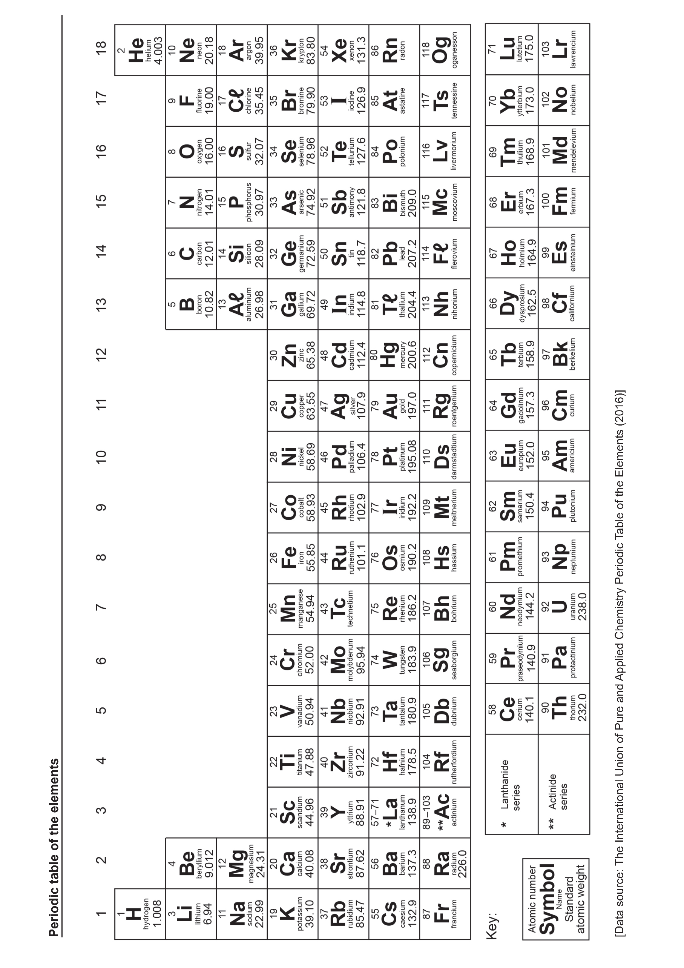

## Ions and molecules for year 10 General Chemistry

|  |  |  |  |
| --- | --- | --- | --- |
| +1 Charge | | -1 Charge | |
| hydrogen  lithium  sodium  potassium  silver  ammonium | H+  Li+  Na+  K+  Ag+  NH4+ | fluoride  chloride  bromide  iodide  hydroxide  nitrate  ethanoate (acetate)  hydrogen carbonate  hydrogensulfate | F-  Cl-  Br-  I-  OH-  NO3-  CH3COO-  HCO3-  HSO4- |
| +2 Charge | | -2 Charge | |
| magnesium  calcium  barium  zinc  strontium  cobalt (II)  manganese (II)  copper (II)  iron (II)  lead (II)  nickel (II) | Mg2+  Ca2+  Ba2+  Zn2+  Sr2+  Co2+  Mn2+  Cu2+  Fe2+  Pb2+  Ni2+ | oxide  sulfide  carbonate  sulfate | O2-  S2-  CO32-  SO42- |
| +3 Charge | | -3 Charge | |
| aluminium  iron (III)  chromium (III) | Al3+  Fe3+  Cr3+ | nitride  phosphate | N3-  PO43- |

|  |  |
| --- | --- |
| **Covalent compounds with specific names:** | |
| **Hydrochloric acid HCl**  **Ethanoic (acetic) acid CH3COOH**  **Nitric acid HNO3**  **Sulfuric acid H2SO4** | **Carbonic acid H2CO3**  **Water H2O**  **Ammonia NH3**  **Hydrogen peroxide H2O2** |